BAND / ORGANISATION NAME:
Beatle: |  |  | John | Paul | George | Ringo
Client’s Name:
Client’s Email Address:
Jacket Fit (Slim or Regular):
Trouser Fit (Slim or Regular):
Height:
J1 | 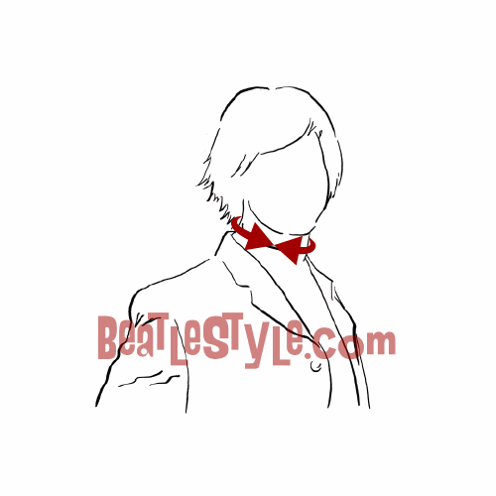 | Neck  (measured on skin)  This measurement required for made-to-measure shirt only  NOTE – FOR ALL MEASUREMENTS, SEE FULL INSTRUCTIONS ON PAGE 3 BELOW
J2 | 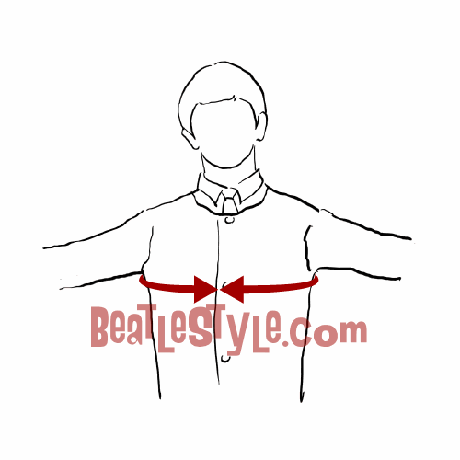 | Chest  (measured over your shirt)
J3 | 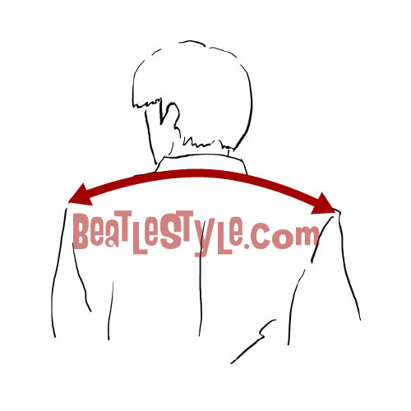 | Full Shoulder Width  (measured on your jacket)
J4 | 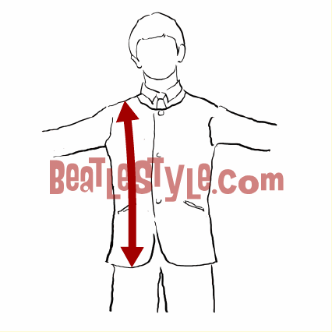 | Jacket Length (measured on front of your jacket)
J5 | 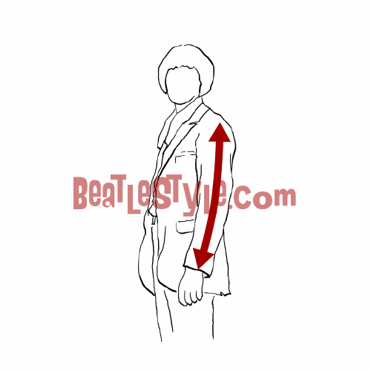 | Sleeve Length (measured on your jacket)
J7 | 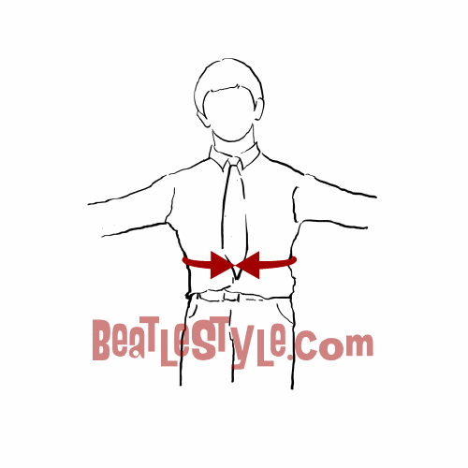 | Jacket Waist (measured over your shirt)
J8 |  | Jacket Hips (measured over your trousers at widest part)
T1 | 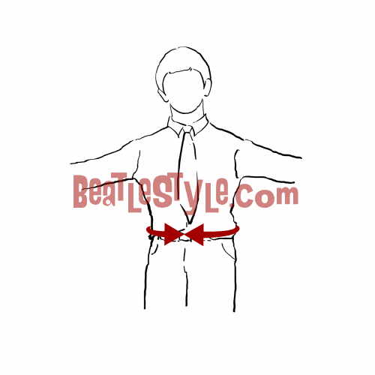 | Trouser Waist (measured over your shirt)
T2 |  | Trouser Hips (measured over your trousers at widest part)
T3 |  | Inside Leg (measured on your trousers)
T4 | 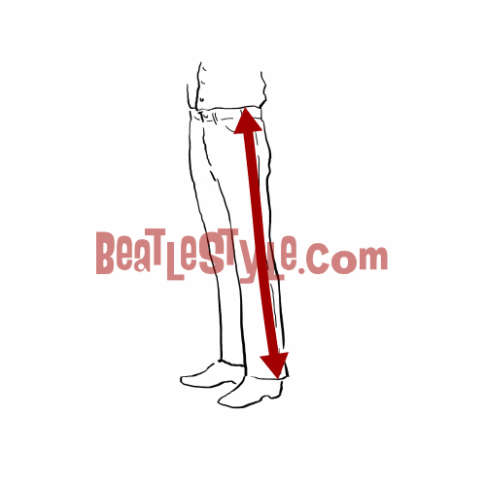 | Outside Leg (measured on your trousers)
T5 | 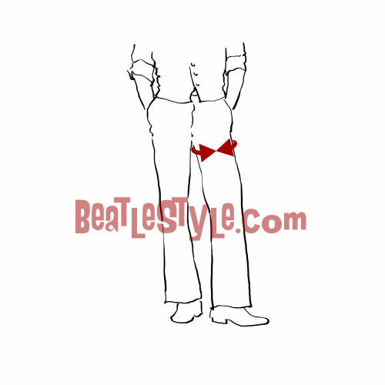 | Thigh (measured on your trousers)
T6 | 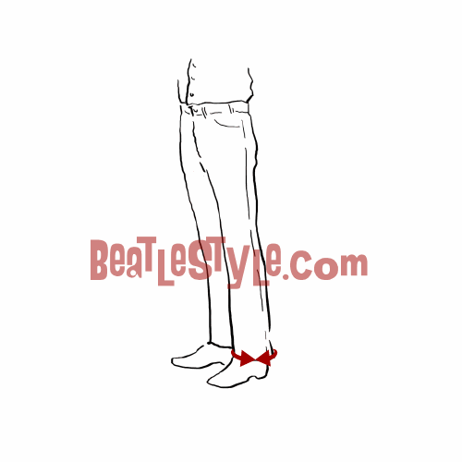 | Leg Hem Width (measured on your trousers)

NOTE – FOR ALL MEASUREMENTS, SEE FULL INSTRUCTIONS ON PAGE 3 BELOW…

Beatle Style Measurements
Why?:
Except for our 60s style ties, every single item of clothing is 100% custom, tailor-made just for you. To achieve a unique, fantastic fit, we recommend you enlist the help of someone and spend 10-15 minutes to obtain a full set of measurements using a fabric tape measure and this online form.
Privacy:
We typically retain your measurements in case you'd like to order something again in the future, but if you wish, once your order is complete, we can delete your measurements from our system - just let us know.
Instructions:
Put on a well-fitting shirt, trousers (not jeans), jacket, and shoes (or 'Beatle' boots), and ask a friend to take the measurements using a fabric tape-measure. Some of the measurements you can get by measuring an existing jacket or pair of trousers that you particularly like the fit of. It's best if you can provide metric measurements but this is not essential.

J1 NECK
Measured on skin by taking a horizontal measurement around your neck. You should be able to fit your index finger in between the tape.

J2 CHEST
Take a horizontal measurement around your chest, just underneath your armpits and over your shoulder blades. You should only just be able to feel the tape on your chest. Stand normally and don't puff out your chest. You should be able to fit your index finger in between the tape and your chest.

J3 SHOULDERS
Take a measurement across the top rear arc of your jacket, from the edge of your left shoulder to the edge of your right shoulder (please note if you are ordering just a shirt, please take this measurement on a well-fitting shirt rather than a jacket). It’s very important that you get this measurement right because it affects the whole look and fit of the jacket or coat.

J4 JACKET / SHIRT LENGTH
Take a vertical measurement down the front of your suit jacket, just next to the collar, where the seam is on your shoulder, to where you would like the jacket to end. The perfect length is generally considered to be where your knuckles are with your arms naturally hanging down. If you prefer, use a jacket you like as a guide. Please note for certain styles (e.g. John's Abbey Road suit, Ringo's Frock coat, all the Sgt. Peppers etc) we will add a certain amount to the standard jacket length provided. Please note if you are ordering just a shirt, please take this measurement on a well-fitting shirt rather than a jacket.

J5/J6 JACKET / SHIRT SLEEVE LENGTH
Take a vertical measurement from where the seams on the shoulder of your suit jacket meet, to where you want the left sleeve of your suit jacket (or shirt) to end. The measurement you provide will be the measurement of your sleeve. For a jacket we recommend that the sleeve should go to the point at which your thumb meets your wrist. (Please note if you are ordering just a shirt, please take this measurement on a well-fitting shirt rather than a jacket). Important – it’s always best to check both arms because there can be a difference! If so, please provide Left sleeve length and Right sleeve length.

J7 JACKET WAIST
Take a horizontal measurement around your stomach, level with the bottom of your ribcage. As a guide this measurement should be where you are widest. Allow some room for breathing/movement.

J8 JACKET HIPS
Take a horizontal measurement around the widest part of your hips. You should not make the tape too snug. You should only just be able to feel the tape when measuring.

T1 TROUSER WAIST
Remove your jacket and take a horizontal measurement around your waist, just inside where you like the top of your trousers to come.

T2 TROUSER HIPS
Take a horizontal measurement around the widest part of your hips. You should not make the tape too snug. You only just be able to feel the tape when measuring.

T3 INSIDE LEG
Take a vertical measurement from the top of your inseam, keeping the tape-measure taut, down to where you wish the bottom of the trousers to end. If you intend to wear the trousers with boots, then please wear boots when you take this measurement as the length will be shorter than if worn over shoes. Please also stand up straight, do not be tempted to look down as this will affect the measurement, use a mirror to look instead.

T4 OUTSIDE LEG
As Inside Leg instructions, but on the outside of your leg and measure from the top of the waistband down to the bottom of the hem.

T5 THIGH
Take a horizontal measurement around the thigh of your trousers at the widest point. You should be able to fit your index finger in behind the tape measure. This is a skin measurement and should be taken just below the crotch.

T6 HEM
This is best measured using a pair of trousers you like the hem width of. Either measure the hem circumference or lie them flat, measure one side and then double the measurement. Please note for certain styles (e.g. the Sgt. Pepper trousers) we will add a certain amount to the standard hem width you provide, to give more of an authentic 'bootcut' fit.

